

CAPSTONE PROJECT 2

PROPOSAL DOCUMENT
CODE: PROPOSAL_v1.2
Date : March 6, 2023
Track and provide travel planner a convenient way to book coach tickets online
Submitted by
Trinh, Nguyen Thi My
Thang, Tran Huu
Huy, Nguyen Huu
Long, Nguyen Hoang
Do, Nguyen Van

Approved by Mentor
Thuan Nguyen Tan, Ph.D

Name Signature Date

INTERNATIONAL SCHOOL OF DUY TAN UNIVERSITY
Project Information
Project acronym
Project Tittle | Track and provide travel planner a convenient way to book coach tickets online.
Start Date | March 2023 | End Date | 2023
Lead Institution | International School, Duy Tan University
Project Mentor | Thuan Nguyen Tan, Ph.D.
Project Manager & contact details | Thang Tran Huu  Email: thnagtran@gmail.com  Tel: 0707145485
Partner Organization
Project Web URL
Team members | Name | Email | Tel
 | Long Nguyen Hoang | Long94079@gmail.com | 0935026735
 | Huy Nguyen Huu | Huynguyen291098@gmail.com | 0905067246
 | Do Nguyen Van | Donguyen2801@gmail.com | 0392219299
 | Trinh Nguyen Thi My | Nguyenthimytrinh1610@gmail.com | 0378343128

Proposal Document

Document Title | Proposal
Reporting Period | August 2022
Author(s) & project | Bao, Huynh Viet
Role | Viet, Tran Hung | Member
 | Huy Nguyen Huu | Member
 | Do Nguyen Van | Member
 | Trinh Nguyen Thi My | Member
Date | 2023 | Filename | Proposal_v1.2
URL
Access | Project and CMU Program

Document History
Version | Date | Comments
V1.0 | 03 March 2023 | Draft for comment
V1.1 | 04 March 2023 | Draft for comment
V1.3 | 05 March 2023 | Official

Document Approvals: The following signatures are required for approval of this document.
Thuan Nguyen Tan  Mentor |  | Date

1. Introduction 1
1.1. Purpose 1
1.2. Scope 1
1.3. References 1
2. Project Overview 2
2.1 Project definition 2
2.2 Business needs/ User needs 2
2.3 Prior Art: 4
2.4 Proposed Solution 4
2.4.1 Project goal 4
2.4.2 Introduction IBM Bluemix 5
2.4.3 Introduction GPS 5
2.4.4 System overview 6
2.4.4.1 System context 6
2.4.4.2 System context description 6
2.4.5 Technical Constrains 7
3. Master Plan 8
3.1 Scrum Process 8
3.2 Master plan 9
4. Organization Management 9
4.1.1 Human Resource 9
5. Cost Estimation 10
6.Project Constraints 11
7. Conclusion: 11
8. References: 12

9.Attachment: 12

Introduction

Purpose
The purpose of the proposal is to:
- Define the business need and problem in detail.
- Provide solutions for business needs and show the overview of system architecture.
- Provide overview about resources, schedule, solution and budget for the project.

Scope
This document provides an overview of project will be developed. It includes the description of business need, the proposed solution, financial forecast and some constraints that involved in the project.
The document provides a comprehensive master plan for each phase of software development based on the processes that have been selected.
This document is made for senior management to put forward a proposal.

Project Overview

Project definition
To builid an mobile app call “Track and provide travel planner a convenient way to book coach tickets.”. with fully features for user can find information about all bus tickets in Vietnam. Users can refer to famous tourist destinations in Vietnam easily.

Business needs/ User needs
Previously, waiting in line for hours at the pier and bus station was a familiar image. To buy a bus ticket, people must go to the place to buy it. Especially in the holidays, buying bus tickets becomes an obsession for many people. BusConnect is the solution to this problem.
BusConnect is currently the largest operator and route information aggregator website in Vietnam and therefore, we have the largest stock of tickets for customers to choose from on our website.
The benefits that BusConnect brings to you:
- You can choose the car company, trip, number of seats according to your needs.
- You can book tickets online, call the operator or buy tickets at BusConnect's agents.
- You can choose and compare prices and quality from 2000+ car brands.
- You are given reviews and comments about the quality of car manufacturers, drivers, and employees.

Prior Art:
Up till now, there are few websites which has introduced information about the ethnic of Viet Nam, but the information is inadequacy and very difficult to find, to use it.
Example:
- https://www.traveloka.com/

Proposed Solution
Our team recommends building a “Track and provide travel planner a convenient way to book coach tickets online.” website with fully features for users: Search for bus ticket information and book cheap bus tickets quickly, and also have useful travel information. With feature, the user can learn about people in Viet Nam easier.
Our team is based on the requirements and come up with solutions and project implementation.
Application is Website,this software is design for user who is student, tourists …and other people who want to know about Vietnamese.

Project goal
The goal of project is to build the “Track and provide travel planner a convenient way to book coach tickets online” website with more functions that meet customer needs within budget and schedule successfully:
- Find information about bus tickets users want to know.
- Share travel information.
- Define the location of user.
- User guide.

Introduction IBM Bluemix
Bluemix is the latest cloud offering from IBM®. It enables organizations and developers to quickly and easily create, deploy, and manage applications on the cloud. Bluemix is an implementation of IBM's Open Cloud Architecture based on Cloud Foundry, an open source Platform as a Service (PaaS). Bluemix delivers enterprise-level services that can easily integrate with your cloud applications without you needing to know how to install or configure them. This article gives a high-level description of Cloud Foundry and Bluemix and outlines the features and services that were part of the open beta of Bluemix, which make it a compelling PaaS in the market today.

Introduction GPS
The Global Positioning System (GPS) is a satellite-based navigation system that was developed by the U.S. Department of Defense (DoD) in the early 1970s. Initially, GPS was developed as a military system to fulfill U.S. military needs. However, it was later made available to civilians, and is now a dual-use system that can be accessed by both military and civilian users.GPS provides continuous positioning and timing information, anywhere in the world under any weather conditions.

System overview

System context
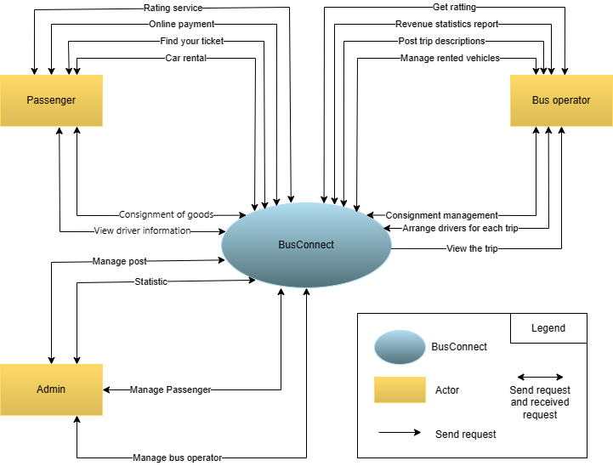
Figure 2.6.1: System context overview

System context description
Passenger has responsibility to:
      - Find bus tickets through trip posts
      - Rent a car at your destination
      - Deposit goods for bus
      - Rating service when completing the trip
      - Online payment on website
      - View your trip's driver information
    - Bus operator has responsibility to:
      - Post trip descriptions for customers
      - Manage rented vehicles
      - Consignment Management of passenger
      - Get Customer Reviews
      - Revenue statistics by each trip
      - Streamline drivers for each trip
      - View information while on a trip
    - Admin operator has responsibility to :
      - Manage passenger and bus operator
      - Statistic system
      - Post management system

Technical Constrains
Technicals for Buiding Project
  - Language: Java, JavaScript, HTML, CSS, Angular
  - Client: Android version from 4.0 🡪 7.0
  - Framework: Java JDK
  - Operation: Android studio, Visual studio code
  - Database: Firebase (Non-Sql).

Business constraints
- Resource: 5 people.
- Budget: 3000$.
- Time: The project must be completed within 3 months.

Master Plan

Scrum Process
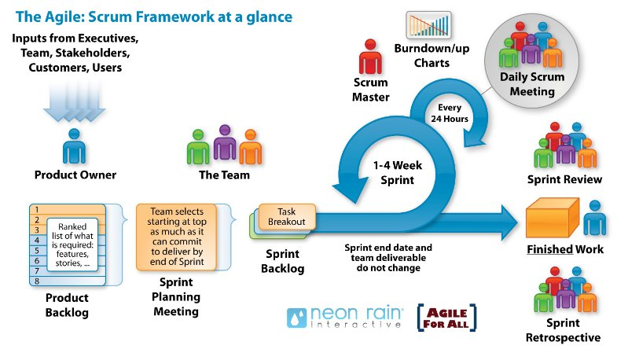
Figure: General SCRUM Process
- Scrum is an iterative and incremental agile software development framework for managing software projects and product or application development.
- Scrum focuses on project management institutions where it is difficult to plan ahead.
- Mechanisms of empirical process control, where feedback loops that constitute the core management technique are used as opposed to traditional command-and-control management.
- Its approach to planning and managing projects is by bringing decision-making authority to the level of operation properties and certainties.

Master plan

NO | Task Name | Duration | Start | Finish
1 | Start Up | 15 days | 06/03/23 | 21/03/23
1.1 | Project Kick Off Meeting | 1 day | 01/03/23 | 01/03/23
1.2 | Discuss about project ideal | 2 days | 02/03/23 | 04/03/23
1.3 | Create Document for project | 7day | 04/03/23 | 11/03/23
2 | Development | 78 days | 21/03/23 | 25/05/23
2.1 | Sprint 0 | 1days | 11/02/23 | 11/02/23
2.2 | Sprint 1 | 25days | 11/03/23 | 06/04/23
2.3 | Sprint 2 | 25 days | 06/04/23 | 01/05/23
2.4 | Sprint 3 | 25 days | 01/05/23 | 25/05/23
3 | Project’s Meeting | 1 days | 24/05/23 | 25/05/23
4 | Final Release | 3 days | 25/05/23 | 28/05/23

Organization Management

Human Resource
- Team’s Information

Full Name | Phone | Email | Position
Msc. Nguyen Tan Thuan |  |  | Mentor
Huynh Viet Bao |  |  | Team Leader
Tran Hung Viet |  |  | Team Member
Nguyen Huu Huy | 0905067246 | Huynguyen291098@gmail.com | Team Member
Nguyen Van Do | 0392219299 | Donguyen2801@gmail.com | Team Member
Nguyen Thi My Trinh | 0378343128 | Nguyenthimytrinh1610@gmail.com | Team Member

Cost Estimation
The following outlines the cost to complete all the identified components for the project.
No. | Phase | Milestone | Cost( 2 hours/day)  USD
1. | Start-up | STU | $120
2. | Development | SPR 0 | $32
2. | Development | SPR1 | $400
2. | Development | SPR2 | $970
2. | Development | SPR3 | $880
3. | Other costs | OTH | $792
4. | Project’s Meeting | PM | $20
5. | Final Release | FR | $35
6. | Total |  | $3.249

Project Constraints
Constraint | Constraints Description | Guidelines for Acceptance
Economic |  | Elements for consideration are design costs, production costs, maintenance costs, operating costs, and sales price
Environmental |  | The impact of the design on the environment as well as the impact of the environment (e.g. temperature range, humidity, vibration, electromagnetic interference immunity, and shock) on the design should be considered. Design for recycling and design to use recycled materials should also be considered
Ethical |  | Ethical considerations can be broad. Areas that are typically addressed include intellectual property, reverse- engineering, privacy, security, and the conflict between cost and safety
Public health, safety, and welfare |  | Includes safety standards as well as the impact of the design on users (for example, electrical or physical hazards)
Social and Global |  | Addresses aspects such as benefits, risks, the man-machine interface, the acceptance of products by the intended user or by society at large, and global and socially responsible engineering.
Cultural |  | Which cultural characteristics could influence the approach?  How do the design from different cultures differ?
Sustainability |  | Refers to the sustainability of resources, including material, energy, supplies, manufacturing techniques, personnel, operation, and the need for additional infrastructure, as well as the sustainability of the design including reliability, lifetime, durability, reusability, maintainability.

Conclusion
People's travel needs are mainly via passenger cars, but most of the bus operators are still managed in the traditional way and are facing painful problems when it takes time to book, edit and write tickets. hand drying paper, situation 3 4 customers have demand to book tickets, slow down the booking process, difficult to control the occupancy rate, inventory management, leading to limitations in vehicle operation such as difficulty receiving tickets far from the date Dare to take many orders, tired of manual control of revenue, profit of ticket sales, robbing goods every day. Busconnect was born to solve the above problems of the garage.
The project team will develop this system within 14 weeks with a budget of 3000 dollars for 5 members. We ensure compliance with schedule, budget and on-time product delivery. We are determined to together with consensus, solidarity, research solutions to overcome challenges and manage progress to bring the project to success.

References
No. | References | Document Information
1 | Scrum Model | https://en.wikipedia.org/wiki/Scrum_(software_development)
1 | Scrum Model | https://www.atlassian.com/agile/scrum
1 | Scrum Model | https://www.digite.com/agile/scrum-methodology/
1 | Scrum Model | https://docs.microsoft.com/en-us/azure/devops/boards/sprints/b est-practices-scrum?view=azure-devops
1 | Scrum Model | https://www.scrum.org/resources/scrum-guide
2 | Technical | https://cloud.google.com/dialogflow/docs/
2 | Technical | https://reactnative.dev/docs/getting-started
2 | Technical | https://congdongchatbot.com/co-the-phan-loai-chatbot-nhu-the- nao
2 | Technical | https://medium.com/@ngoquocvinh/ch%C6%B0%C6%A1ng-1  -c%C3%A1c-lo%E1%BA%A1i-chatbot-bf10ed7c2a09
2 | Technical | https://oabigroup.com/blog/2019/07/19/5-chatbot-pho-bien-o-vi et-nam/
2 | Technical | https://congdongchatbot.com/so-sanh-chatbot-su-dung-ngon-ng u-tu-nhien-va-chatbot-kieu-menu-button/
3. | Software Engineering Standards | https://www.nws.noaa.gov/oh/hrl/developers_docs/General_So ftware_Standards.pdf
3. | Software Engineering Standards | https://standards.ieee.org/standard/12208-2017.html
3. | Software Engineering Standards | https://sw-eng.larc.nasa.gov/

Attachment: DESCRIPTION OF PRODUCT REQUIREMENTS FORM

